1. In early stages it would probably be best to only show a demo, to demonstrate what was accomplished up until that point until a more polished finish product is created for the user to try out. During the review the team and customer goes over what was finished and what else might be needed, the demo shows ALL that is finished instead of just what the user might use and ignore other content previously asked for. However both at the same time would be ideal, make a demo video of the completed features and let the user run through it as they would. This also shows and deficits of the project by someone who hasn't stared at every aspect of it.

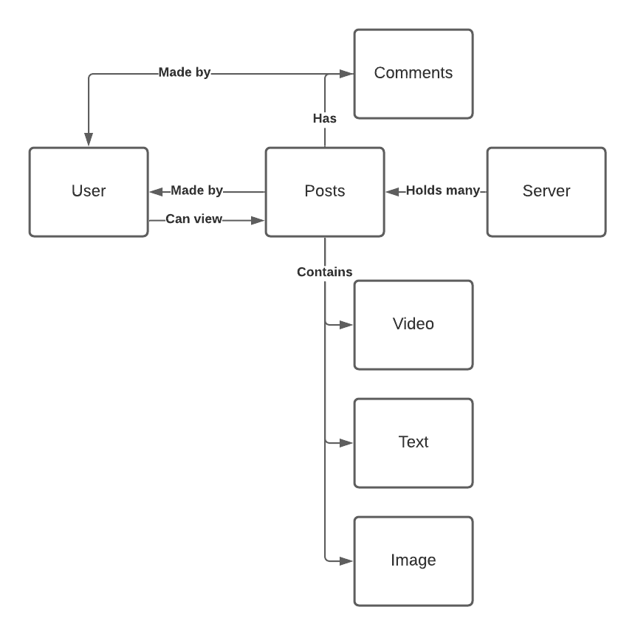

1. A project that has all requirements upfront and will receive no modifications during its development. Cost is low and production time is low.